Manufacturing of WC-17Co 3D-objects by Laser Powder Bed Fusion followed by heat-treatment

Kevin Papy¹, Julien Favre², Alexey Sova¹, Andras Borbely², Philippe Bertrand¹,
Jean-Marc Staerck³

1 - University of Lyon, Ecole Centrale de Lyon - ENISE, LTDS, UMR CNRS 5513, Saint Etienne, France
2 - Mines Saint-Etienne, Univ Lyon, CNRS, UMR 5307 LGF, Centre SMS, F - 42023 Saint-Etienne France
3 - Technogenia, Saint-Jorioz, France.

Abstract:
Conventional tungsten carbide (WC) cermet parts containing a cobalt matrix phase are generally produced via powder sintering. In this study it is shown that cermet parts can also be produced by laser powder bed fusion from WC-17Co powder precursor. Optimal process parameters were found for manufacturing without preheated building plate. Micro-structural analysis revealed noteworthy porosity fraction (1.41%) as well as the presence of small-scale cracks in the as-built specimens. It is further shown that most of these defects can be eliminated by heat treatment at ambient pressure or by hot isostatic pressing. Heat treatment also led to the dissolution of the fragile W₂C phase. Hardness test results indicate that the performance of the AM parts was comparable to that of a reference produced via powder sintering. The work is a successful demonstration of manufacturing of cermet parts using laser powder bed fusion.

Keywords: Cermet, tungsten carbide, laser powder bed fusion, hot isostatic pressing, hardness

Introduction
Laser power bed fusion (L-PBF), also known as selective laser melting (SLM), is an additive manufacturing (AM) process used for the production of functional parts with complex shape using a metallic powder as feedstock material. In L-PBF a laser beam melts a powder layer which after solidification builds up the three-dimensional part layer-by-layer[1]–[3]. The final physical properties such as roughness, density, porosity, cracking propensity depend on process parameters including the laser power, scanning speed, and powder bed thickness [4]–[7].
Tungsten carbide/cobalt (WC-Co) cermets are extensively utilized in the manufacture of cutting tools. The properties and applicability of tungsten alloys depend significantly on the WC content (from 80 to 97 wt.%) as well as the binder phase composition. In general WC-Co cermets exhibit exceptional hardness, low friction coefficients, and high melting points, all of which contribute to a high wear resistance.
WC-Co parts are classically manufactured by powder sintering [8]–[12]. The layer-by-layer AM method could significantly increase tool design complexity and potentially improve tool performance. Several studies regarding L-PBF manufacturing of WC-Co parts are available in the literature [13]–[17]. Generally, it is reported that manufacturing good quality parts is challenging due to the high melting point, high thermal conductivity, and brittle nature of the as-built parts. In most cases their integrity was low owing to the presence of long cracks and pores. For example, Uhlmann et al. [18] reported that WC-17Co parts manufactured by L-PBF at low (185 J/mm³) and high (1667 J/mm³) energy densities exhibited substantial porosity and cracking. They also established that parameters such as beam focalization, layer thickness, laser power, and scan speed affected the relative density of the WC-17Co material. The work provides an interesting optimization study of process parameters, but the possible benefit of post heat-treatment is not explored. Khmyrov et al. [19] used a mixture of WC-75Co and WC-50Co powders to determine the optimal WC content at which cracking can be avoided, mainly caused by the presence of the ternary Co₃W₃C brittle phase. It was found that cracking of AM parts could be avoided only at low percentages of WC, which is not interesting for applications (compared to cermets obtained by sintering). The main objective of the study conducted by Schwanekamp et al. [20]–[22] was to reduce the porosity and crack frequency by preheating the support plate. Preheating to 800 °C resulted in a significant reduction in crack prevalence and porosity, but a large number of micropores still remained. Further post-treatment by hot isostatic pressing (HIP) resulted in a significant improvement of the material density. The work concluded that the use of a preheated building plate was essential for the successful manufacture of WC-Co parts using L-PBF. The positive effect of HIP reported in their work is encouraging. Therefore, further studies exploring its applicability limits in terms of the microstructure of AM parts could help developing energy efficient methodologies.
Considering the above literature results it can be concluded that L-PBF manufacturing of WC-Co parts remains challenging. Preheating of the building plate to a high temperature allowed the manufacturing of solid samples with some residual porosity that could be eliminated through HIP post-treatment. However, in the absence of a preheating plate the manufacturing of complex-shaped WC-Co parts, even with high internal porosity, was not possible owing to crack formation and to the destruction of the part during cutting from the plate. In addition, it should be confirmed whether the HIP process is able or not to heal the defects formed during AM. Additional information concerning microstructure changes during HIP would be also helpful to understand final physical properties of the manufactured parts.
Present article focuses on the AM of parts using the commercial WC-17Co material and addresses three essential points as illustrated on Figure 1. First, the possibility to produce complex shapes by L-PBF without using a preheated plate will be tested and the optimal process parameters will be determined. In a second step the actual benefits of the HIP post process will be evaluated. Especially a comparison with a conventional heat treatment will demonstrate the importance of the applied pressure. Finally, the hardness performance of the produced parts will be tested.
Figure 1 : Global scheme of the study with three main steps: L-PBF process, post heat- treatment and hardness tests

Material and methods

L-PBF Equipment
Pro X 200 DMP equipment supplied by 3D Systems was used in the study. The volume of the working chamber where the parts were manufactured was 140 × 140 × 125 mm³. The L- BF machine was equipped with a 400 W fiber laser having a wavelength of 1070 nm. To prevent oxidation the working chamber was filled with nitrogen during manufacturing.

It is important to note that the analysis of the laser beam shape revealed a significant effect on the energy distribution in the beam. In particular, at powers higher than 200 W and long exposure times the energy distribution changed from a Gaussian spot to a ring shape. The energy distribution surfaces measured at laser powers of 130 W and 300 W are presented in Figure 2. Evidently, this shape change significantly complicates the optimization process. To avoid its influence the maximum laser power was limited to 160 W so that the shape of the energy distribution surface remained close to Gaussian. The spot diameter was 130 µm.
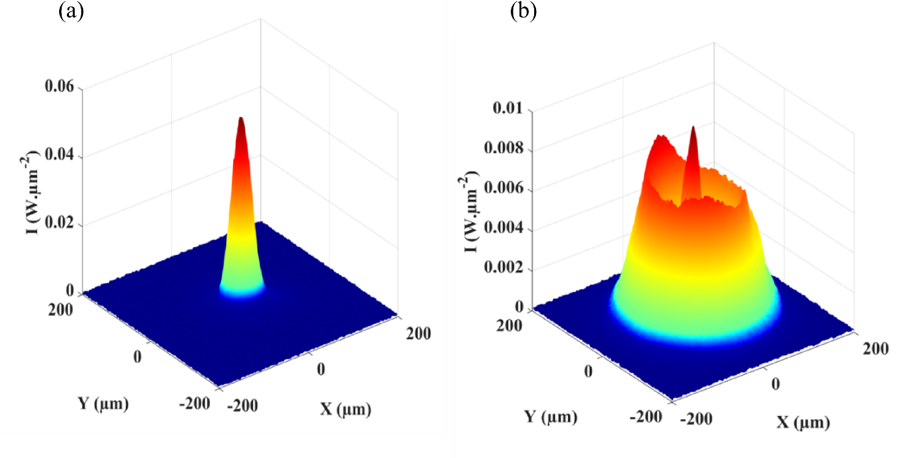
Figure 2 : Intensity distribution surfaces at (a) 130 W and at (b) 300 W (laser power in the focal plane)

Powder material
Agglomerated-sintered WC-17Co powder with a particle size distribution of 15–53 µm (Oerlikon Metco) was used in this study. The powder was initially developed for thermal spray applications such as HVOF and HVAF. SEM images of the particles are shown in Figure 3. It is evident that the particles are quasi-spherical in shape. The average size of the WC grains (dark grey) is in the 1-5µm range. The carbide grains are uniformly distributed in the cobalt matrix (light grey).

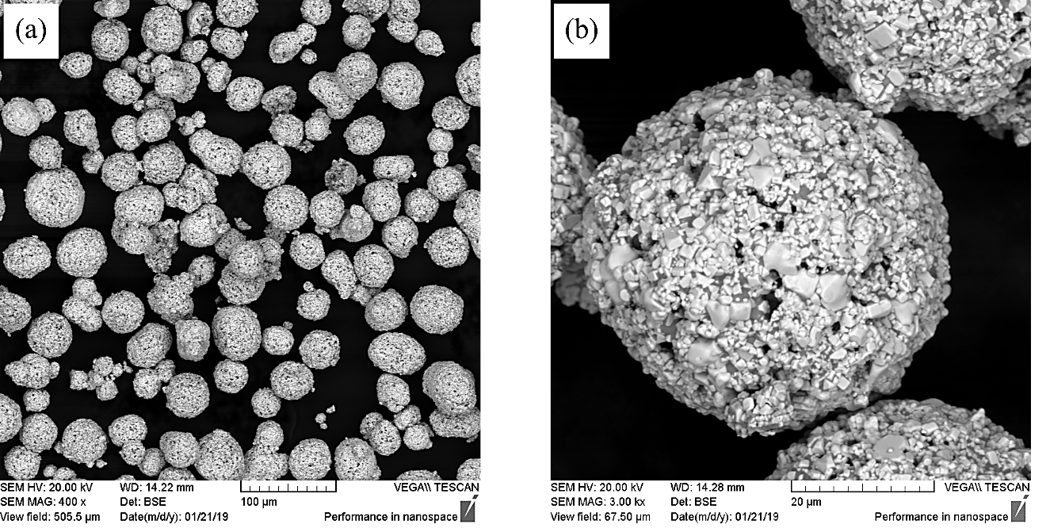
Figure 3 : SEM images of the WC-17Co particles at different magnification (a) x400 and (b) x3000
Inductively coupled plasma mass spectrometry (ICP-MS) analysis (see Table 1) indicates that the chemical composition was within the range stated by the supplier (C: 4.7 – 5.5, Co: 14.5 – 19.5).
Table 1. Chemical analysis of the initial powder according to ICP-MS
Element [wt.%]
W | C | Co
76.4 | 5.2 | 18.4

X-ray diffraction (XRD) was employed for phase analysis using an X'PertPro MPD diffractometer with CuKα radiation. Phase quantities were obtained from Rietveld analysis performed with the MAUD software [23]. The powder pattern shown in Figure 4 was fitted with an Rwp = 4.1% ($χ^{2}$ = 3.4), which resulted in mass fractions of 90±6% for the WC phase (space group P-6 m2) and 10±4% for the Co phase (space group Fm-3m). The phase fraction errors are relatively large, and the results correspond to the lower limit of the nominal composition stated by the manufacturer. The crystallite sizes in the WC and Co phases were 340 and 210 nm, respectively. Additionally, the microstrain in the Co phase was large (~${2∙10}^{-3}$), whereas it was minimal in the WC phase (~${4∙10}^{-4}$).
The difference between the ICP-MS and XRD results may be related to differences in micro absorption and crystallite size of the two phases.
Figure 4 : XRD pattern of the WC-17Co powder used for L-PBF process

Various particle properties, such as shape, size distribution, flowability, apparent density and tap density were also analyzed. Powder morphology analysis indicated that the particles were largely spherical with an equivalent diameter of d₁₀= 24.3 µm, d₅₀=47.8 µm and d₉₀=73.4 µm. The powder flowability results were obtained using a Hall flowmeter in accordance with ASTM B527 and ASTM B21, and are presented in Table 2 together with the tap and apparent densities.

Table 2. Summary of powder properties
Flow rate [s/50g] | 12.4 ± 0.3
Tap density [g/cm³] | 5.9 ± 0.02
Apparent density | 5.21 ± 0.03
Hausner index | 1.13 ± 0.02
Carr index | 11.43 ± 0.02

Post-treatment processes
Cube-shaped samples with dimensions of 10 × 10 × 10 mm³ manufactured using L-PBF were used for post-treatment. The first batch of samples was heat-treated (HT) in an oven at 1450 °C under nitrogen atmosphere for 5h. The second batch was subjected to capsule-free HIP, which is a cycle applied during industrial processes. The HIP process was performed in several steps. First, the temperature was gradually increased from room temperature to 1000 °C over 15h under normal pressure, then it was then elevated to 1450 °C at a heating rate of 5 °C/min. The furnace was maintained at a pressure of 40 MPa for 5h. Cooling to room temperature was performed in the HIP chamber at a rate of 6 °C/min.

Structural and mechanical properties
The relative density of the manufactured parts was determined employing the Archimedes method using ASTM-B962 as well as the analysis of scanning electron microscope (SEM) images (using ImageJ [25]). The microstructure and elemental distribution were analyzed using a Zeiss Supra 55VP v2 SEM. Vickers hardness (HV) was determined by applying a load of 30 kg for 10 s to all samples. Palmqvist toughness were determined by cracks propagation measurement after indentation test [24], [25].

Results and discussion

Optimization of process parameters
In the first step, the parametric window of the L-PBF process was determined. The principal purpose of these experiments was to determine the parameters enabling the production of materials with the lowest amount of porosity and cracks. Initially, single tracks were deposited with a powder layer thickness of 30 µm. The power and scan velocity were varied from 100 to 160 W and from 30 to 200 mm/s, respectively. Table 3 summarizes the parameter ranges tested in the first stage.

Table 3. Ranges of L-PBF manufacturing parameters applied in the experiments
Layer thickness [µm] | 30
Range of laser power [W] | 100-130-160
Range of scan speed [mm/s] | 30-100
Range of hatching distance [µm] | 140-200
Inert gas | Nitrogen

Observation of the track shape allowed to conclude that stable tracks were formed only when the scanning speed was in the 30-40 mm/s range at a laser power of 130 W. Following the single-track experiments, 3D objects with simple geometries (cubes and parallelepipeds) were manufactured. Numerous factors can affect the process results, such as the laser power, scan speed, hatch spacing, layer thickness, and scanning strategy. These factors are important because re-melting depends on the amount of the energy density (E_{v}) absorbed during the process [26], which is defined by the following equation:
E_{v} = $\frac{P}{Vs ×Hd ×l}$ (1)

where E_{v} is the energy density (J/mm³), P is the laser power (W), Vs is the scanning speed (mm/s), Hd is the hatch distance (mm) and l is the layer thickness (mm).
Similar approaches based on energy density optimization in the L-PBF process have already been successfully applied several times [27], [28]. Furthermore, hexagonal and zigzag scanning strategies were applied to produce WC-Co cubes (Figure 5).
Figure 5 : Schematic illustration of (a) zigzag and (b) hexagonal scanning strategies

To analyze porosity and other defects the samples were cut parallel to the building direction. Figure 6 (bottom) shows the relationship between sample density and energy density. The plot in Figure 6 (top) indicates that samples with the higher density (98,9%) were manufactured using an energy input of 602 J/mm³ and the hexagonal scanning strategy (Figure 6b). The samples manufactured at a lower energy density (hexagonal scanning strategy) contained significantly more pores and with larger sizes (Figure 6a). This dramatic increase in porosity is related to the lack of fusion of the WC-Co powder. An increase in the energy density above 602 J/mm³ led to crack formation at the layer interface. The samples manufactured at 833 J/mm³ using the hexagonal scanning strategy contained abundant cracks and had the lowest density, which indicates a high level of residual stress. The optimum energy density for manufacturing in the zigzag scanning strategy was found to be 560 J/mm³. For comparison, the optimal Ev level of the Co-28Cr-6Mo alloy is appreciably lower (~200 J/mm³) and its porosity is close to zero [29].

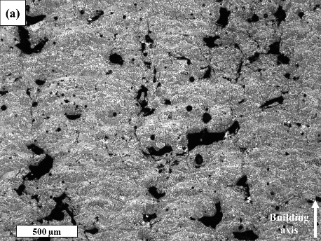 | 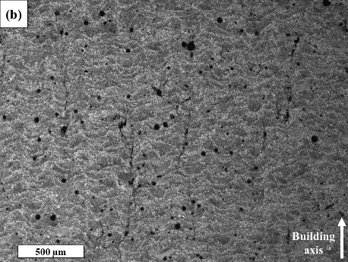 | 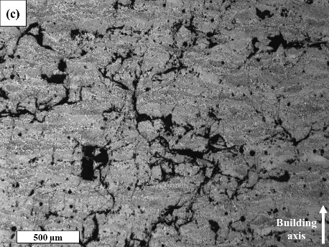
Figure 6 : Bottom: plot of sample density vs. energy density for zigzag and hexagonal scanning strategies. Top: SEM images of samples manufactured via the hexagonal scanning strategy at (a) low, (b) medium, and (c) high energy densities

The density of the zig-zag-generated samples was lower than for the hexagonal scanning strategy, therefore, the final batch was produced using the latter. An image of the building plate and the manufactured samples is shown in Figure 7. Blocks (50 × 25 × 10 mm³) were built for abrasive wear tests, and cubes (10 × 10 × 10 mm³) and cylinders (Ø20 × 10 mm) for various characterizations. Lattice-structured cubes were also built to test the limits of manufacturing using cermet powder.
Figure 7 : Image of the building plate and the samples manufactured for various analyses

Microstructure and composition of the as-built samples
SEM images of the as-built sample produced at 602 J/mm³ applying the hexagonal manufacturing strategy are shown in Figure 8.
Figure 8 : SEM images of the as-built sample at (a) x500, (b) x1000, and (c) x5000 magnifications

Microstructure observations revealed that unlike the powder, the as-built samples contained significantly finer carbide grains. In particular, ample grains with a size of ~1-3 µm were visible. Some submicron carbide inclusions were also present in the metal matrix. Short cracks and pores were visible throughout the sample (Figure 9), but they did not affect the integrity of the cube.
Figure 9 : Secondary electron SEM image of the as-built sample illustrating the presence of cracks, pores, and fine carbide grains

The pore size distribution evaluated with ImageJ is shown in Figure 10 and shows the effect of post-treatment on the pore size and number for all analyzed cases. Ten different micrographs were recorded at randomly selected positions on each cross section using a magnification of x50. The histogram shows the evolution of the porosity of the different manufactured samples and the influence of the heat treatments. The as-built sample has numerous porosities in the range of 5µm to 40µm. The HIP treatment eliminates porosities of the order of 5µm and considerably reduces porosities of a size greater than 20µm. TTh treatment reduces larger porosities, as well as smaller ones, but unlike HIP does not eliminate them completely. The effect of the pressure applied during HIP highlights the effectiveness of this treatment in removing porosities.

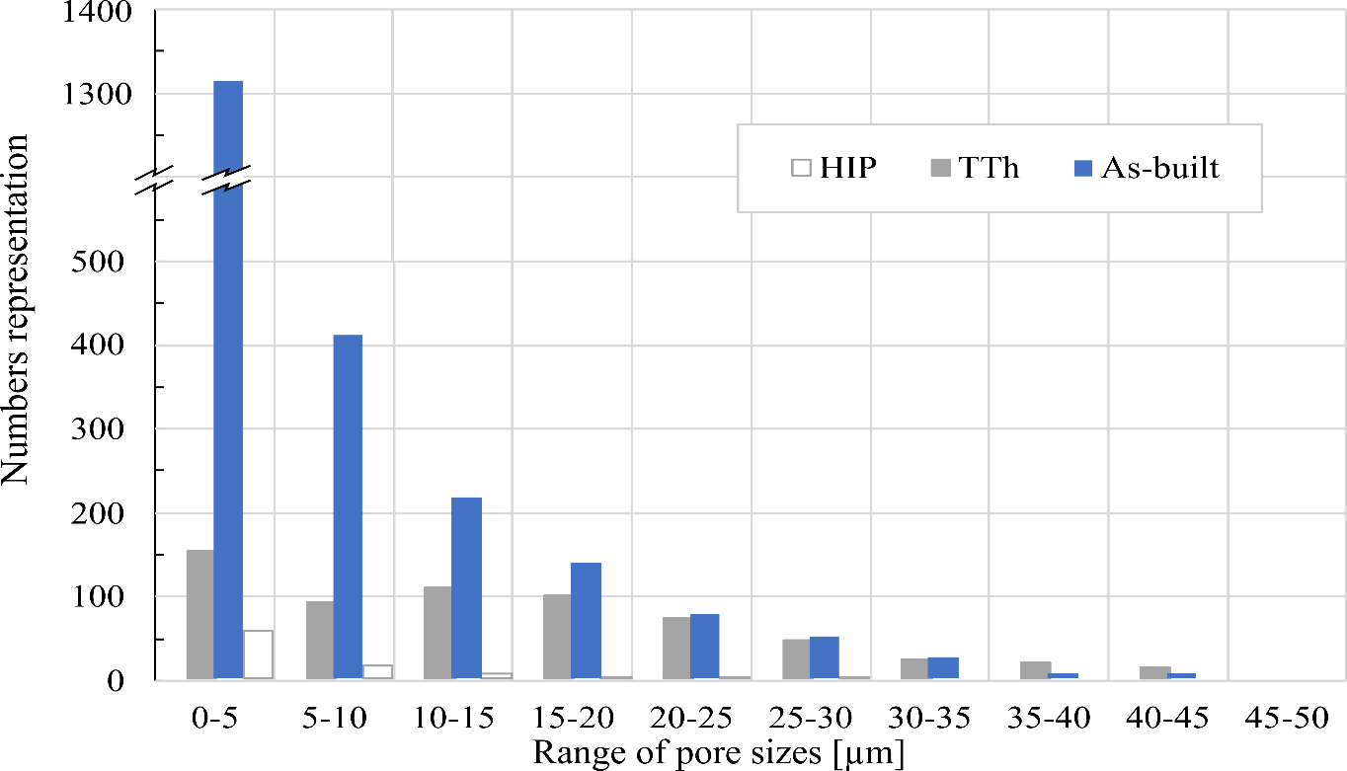
Figure 10 : Pore size distribution in the as-built samples and after heat treatment

The XRD pattern corresponding to the as-built sample is shown in Figure 11. Compared to Figure 5 (containing the WC and Co phases only) complex carbides formed during the L-PBF process are also visible, caused by decarburization phenomena. In particular, the W₂C phase and the ternary Co₃W₃ C and Co₃W₉ C₄ phases were present and are caused by the partial diffusion of carbides grains. These phases have compact hexagonal (P63/mmc), cubic (Fd-3m), and compact hexagonal structures (P63/mmc), respectively. Formation of the fragile W₂C and Co₃W₃ C phases promote sample cracking during the L-PBF process [30], [31]. In conventional powder sintering the W₂C phase is considered undesirable and should be avoided.

Figure 11 : XRD pattern of the as-built sample

Microstructure and composition of the samples after heat treatment and HIP
Heat treatment of the as-built samples significantly modified their microstructures and crystallographic phases. In particular, cracks were no longer visible (Figure 12a), because high temperatures promote material diffusion, allowing for crack closure and sintering of contact surfaces.
Figure 12 : Sample microstructures after heat treatment at (a) ambient pressure and (b) HIP

However, heat treatment at ambient pressure had a limited effect on the porosity. According to the image analysis results, the relative density of the HT samples was 98.63%, with the disappearance of many of the smallest pores. In contrast to heat treatment at normal pressure the effect of HIP on porosity was remarkable. The microstructure shown in Figure 12b has a mass density of approximately 99.99%. . The highest density values were obtained for the HIP-treated samples, confirming the high efficiency of this process for pore closure. Nevertheless, the high relative density of 99.99% can also be related the loss of Co, which might evaporate during L-PBF.

The XRD patterns of the HT and HIP samples presented in Figure 13 are very similar. The phase transformation induced by high-temperature annealing and HIP resulted in the complete dissolution of the fragile W₂C phase, which also has been found in previous studies. Meanwhile, formation of the Co₆W₆C phase with a cubic structure (Fd-3m) was observed in both HT and HIP samples. It can be concluded that the high pressure during HIP treatment did not significantly modify the phase transformation process and that the temperature (1450 °C) during treatments was the key factor influencing the final phase composition.
Figure 13 : XRD patterns of the (a) as-built, (b) HT and (c) HIP-treated samples

  - Macrohardness Vickers
Macrohardness tests were performed on the as-built, HT, and HIP-treated samples. Three measurements per sample were performed according to the standard methods, and the results are shown in Table 4. The mean value obtained for the as-built samples was 1096 HV₃₀, which is close to those obtained for WC-17Co sintered reference parts [34]–[37]. In addition, material cracking was observed near the corners of the indent made on the as-built sample cross-section, which indicated high material brittleness (Figure 14a). The hardness of the HIP-treated (1152 HV₃₀) samples was slightly higher than that of the as-built samples, likely due to their decreased porosity and material integrity improvement. In addition, material cracking was significantly reduced during indentation of the HT and HIP-treated specimens (Figure 14 b and c). This result can be related to the absence of the brittle W₂C phase. The standard deviation of the macrohardness for the HIP and HT samples were lower than those of the as-built samples due to their homogenized structures.
Figure 14 : Overview Vickers indent on the surface of the (a) as-built, (b) HT, and (c) HIP-treated samples

Table 4 : Results of mechanical test
Sample | Density [g/cm³] | HV30
As built | 14,30 ± 0,2 | 1096 ± 45
HT | 14,48 ± 0,2 | 1120 ± 20
HIP | 14,77 ± 0,1 | 1152 ± 17

The results of the hardness test and the bulk density of the as-built and heat-treated samples were comparable to the sintered cermet (Table 4). This confirmed the quality of the material produced by L-PBF is sufficiently high to provide suitable applications [11].

Conclusion
The feasibility of using L-PBF additive manufacturing without a preheated plate to generate dense cermet samples from WC-17Co was successfully assessed. The results can be summarized as follows:
- The manufacture of dense WC-17Co parts using L-PBF without preheated plate is possible.
- Samples with the lowest porosity (1.41%) and highest integrity were obtained using a volume energy density of 602 J/mm³ and a laser beam power of 130 W. The as-built samples contained the brittle W₂C phase and some small-scale pores and cracks.
- The sample structure, density, and hardness can be significantly improved through capsule-free HIP, resulting in close-to-zero porosity. Heat treatment performed at normal pressure eliminated short cracks and the small-scale porosity and enhanced the material hardness.
- Both post-treatment types (at atmospheric pressure and HIP) allowed the dissolution of the undesirable brittle W₂C phase. Other complex carbides, such as Co₃W₃C, Co₃W₉C₄, and Co₆W₆C, observed in the as-built samples were also present after simple heat treatment or HIP.
- The macrohardness of the L-PBF-manufactured WC-17Co parts are very close to the values characterizing sintered reference samples.
- The L-PBF parameters defined in this study can potentially be applied in the manufacture of complex-shaped parts of acceptable density and integrity without fragmentation during manufacturing.

References
[1] C. Y. Yap et al., “Review of selective laser melting: Materials and applications,” Appl Phys Rev, vol. 2, no. 4, 2015, doi: 10.1063/1.4935926.
[2] E. Herderick, “Additive manufacturing of metals: A review,” Materials Science and Technology Conference and Exhibition 2011, MS and T’11, vol. 2, no. 176252, pp. 1413–1425, 2011.
[3] N. Li et al., “Progress in additive manufacturing on new materials: A review,” J Mater Sci Technol, vol. 35, no. 2, pp. 242–269, 2019, doi: 10.1016/j.jmst.2018.09.002.
[4] Ian Gibson, Brent Stucker, and David Rosen, Additive Manufacturing Technologies 3D Printing, Rapid Prototyping,and Direct Digital Manufacturing, vol. Second Edition. 2019. doi: 10.1007/978-1-4939-2113-3.
[5] C. Y. Zhang, Y. P. Ren, and X. S. Chen, “The development situation of selective laser melting metal powder based on 3D printing,” Applied Mechanics and Materials, vol. 518, pp. 12–18, 2014, doi: 10.4028/www.scientific.net/AMM.518.12.
[6] S. Vock, B. Klöden, A. Kirchner, T. Weißgärber, and B. Kieback, “Powders for powder bed fusion: a review,” Progress in Additive Manufacturing, vol. 4, no. 4, pp. 383–397, 2019, doi: 10.1007/s40964-019-00078-6.
[7] B. Zhang, Y. Li, and Q. Bai, “Defect Formation Mechanisms in Selective Laser Melting: A Review,” Chinese Journal of Mechanical Engineering (English Edition), vol. 30, no. 3, pp. 515–527, 2017, doi: 10.1007/s10033-017-0121-5.
[8] C. Chen, Z. Guo, S. Li, Y. Xiao, B. Chai, and J. Liu, “Microstructure and properties of WC-17Co cermets prepared using different processing routes,” Ceram Int, vol. 45, no. 7, pp. 9203–9210, 2019, doi: 10.1016/j.ceramint.2019.01.265.
[9] Z. Roulon, J. M. Missiaen, and S. Lay, “Carbide grain growth in cemented carbides sintered with alternative binders,” Int J Refract Metals Hard Mater, vol. 86, no. September 2019, p. 105088, 2020, doi: 10.1016/j.ijrmhm.2019.105088.
[10] H. M. Ortner, P. Ettmayer, H. Kolaska, and I. Smid, “The history of the technological progress of hardmetals?,” Int J Refract Metals Hard Mater, vol. 49, no. 1, pp. 3–8, 2015, doi: 10.1016/j.ijrmhm.2014.04.016.
[11] R. T. Faria, M. F. Rodrigues, I. de Andrade Esquef, H. Vargas, and M. Filgueira, “On the thermal characterization of a HPHT sintered WC-15% wt Co hardmetal alloy,” Int J Refract Metals Hard Mater, vol. 23, no. 2, pp. 115–118, 2005, doi: 10.1016/j.ijrmhm.2004.11.007.
[12] A. S. Kurlov and A. A. Rempel’, “Effect of sintering temperature on the phase composition and microhardness of WC-8 wt % Co cemented carbide,” Inorganic Materials, vol. 43, no. 6, pp. 602–607, 2007, doi: 10.1134/S002016850706009X.
[13] A. Aramian, S. M. J. Razavi, Z. Sadeghian, and F. Berto, “A review of additive manufacturing of cermets,” Addit Manuf, vol. 33, no. July 2019, p. 101130, 2020, doi: 10.1016/j.addma.2020.101130.
[14] Y. Yang, C. Zhang, D. Wang, L. Nie, D. Wellmann, and Y. Tian, “Additive manufacturing of WC-Co hardmetals : a review,” pp. 1653–1673, 2020.
[15] A. Domashenkov, A. Borbély, and I. Smurov, “Structural modifications of WC/Co nanophased and conventional powders processed by selective laser melting,” Materials and Manufacturing Processes, vol. 32, no. 1, pp. 93–100, 2017, doi: 10.1080/10426914.2016.1176195.
[16] D. Bricin and A. Kriz, “Processability of WC-CO powder mixtures using slm additive technology,” MM Science Journal, vol. 2019, no. June, pp. 2939–2944, 2019, doi: 10.17973/MMSJ.2019_06_2018115.
[17] D. Bricín, Z. Špirit, and A. Kříž, “Metallographic analysis of the suitability of a WC-Co powder blend for selective laser melting technology,” Materials Science Forum, vol. 919, pp. 3–9, 2018, doi: 10.4028/www.scientific.net/MSF.919.3.
[18] E. Uhlmann, A. Bergmann, and W. Gridin, “Investigation on Additive Manufacturing of Tungsten Carbide-cobalt by Selective Laser Melting,” Procedia CIRP, vol. 35, pp. 8–15, 2015, doi: 10.1016/j.procir.2015.08.060.
[19] R. S. Khmyrov, V. A. Safronov, and A. v. Gusarov, “Obtaining crack-free WC-Co alloys by selective laser melting,” Phys Procedia, vol. 83, pp. 874–881, 2016, doi: 10.1016/j.phpro.2016.08.091.
[20] T. Schwanekamp, “Parameter study on laser beam melting of WC- Co at 800 ° C pre-heating temperature,” ICAT Proceedings of 7th International Conference on Additive Technologies, no. October, pp. 78–84, 2019.
[21] Schwanekamp, “Thermal Post-Treatment of Additively Manufactured WC-Co Processed by Laser Powder Bed Fusion,” 2019.
[22] T. Schwanekamp and M. Reuber, “Additive manufacutring of application optimized tungsten carbide precision tools,” 6 th International Conference on Additive Technologies, no. January 2016, pp. 100–114, 2016, doi: 10.1016/S0925-8388(03)00637-6.
[23] “MAUD”, [Online]. Available: http://maud.radiographema.eu/
[24] “Hardmetals - Palmqvist toughness test - ISO28079.” 2009.
[25] B. Roebuck, E. Bennett, L. Lay, and R. Morrell, “Palmqvist Toughness for Hard and Brittle Materials Measurement Good Practice Guide No . 9,” no. 9, p. 48, 2008.
[26] L. N. Carter, M. M. Attallah, and R. C. Reed, “Laser Powder Bed Fabrication of Nickel-Base Superalloys: Influence of Parameters; Characterisation, Quantification and Mitigation of Cracking,” 2012.
[27] J. P. Oliveira, T. G. Santos, and R. M. Miranda, “Revisiting fundamental welding concepts to improve additive manufacturing: From theory to practice,” Prog Mater Sci, vol. 107, no. June 2019, p. 100590, 2020, doi: 10.1016/j.pmatsci.2019.100590.
[28] K. G. Prashanth, S. Scudino, T. Maity, J. Das, and J. Eckert, “Is the energy density a reliable parameter for materials synthesis by selective laser melting?,” Mater Res Lett, vol. 5, no. 6, pp. 386–390, 2017, doi: 10.1080/21663831.2017.1299808.
[29] L. Tonelli, A. Fortunato, and L. Ceschini, “CoCr alloy processed by Selective Laser Melting (SLM): effect of Laser Energy Density on microstructure, surface morphology, and hardness,” J Manuf Process, vol. 52, no. October 2019, pp. 106–119, 2020, doi: 10.1016/j.jmapro.2020.01.052.
[30] R. S. Khmyrov, A. P. Shevchukov, A. v. Gusarov, and T. v. Tarasova, “Phase composition and microstructure of WC-Co alloys obtained by selective laser melting,” Mechanics and Industry, vol. 18, no. 7, 2017, doi: 10.1051/meca/2017059.
[31] H. Ibe et al., “Controlling WC/Co two-phase microstructure of cemented carbides additive-manufactured by laser powder bed fusion: Effect of powder composition and post heat-treatment,” Mater Des, vol. 210, p. 110034, 2021, doi: 10.1016/j.matdes.2021.110034.

